# Lab 05 – Create DB, Create Table based on ERD

This Lab relates to the following Course Learning Requirements:

CLR 1: Follow lab policies and procedures for etiquette, software licensing requirements and lab submissions

CLR2: Use workplace tools to model database design using ER diagrams

CLR3: Map an ERD to a Relational Database

CLR3: Create database backups

Objective:

The objective of this lab is to make sure that student can analyze the ERD and relate it to Relational Database.

# Pre-Lab Instructions:

1. Read Module 5 and Module 6

**Lab Tasks:**

You can proceed with this lab with a starting point of the ER model you created in Lab 4, or directly with SQL

1. Lab 5 is built on top of lab 4. Make sure you are connected to the database.
2. If you do not have the model from Lab 4, you can reimport the file (refer to Lab 4 for instructions).
3. You will be adding two new tables to the car_fuel database created in Lab 4.
4. The two new tables fuel_type and transmission are:
   * fuel_type
     1. Create table with the following attributes and column name.
        1. fuel_type_id int unsigned primary key auto_increment Not Null,
        2. fuel_consumption varchar(200)
   * transmission
     1. Create table with the following attributes and column name.
        1. transmission_id int unsigned primary key auto_increment Not Null,
        2. transmission varchar(20)
5. Add two columns in table fuel_consumption. When creating foreign keys, make sure the key you are referencing has the same attributes.
   1. transmission_id int unsigned
   2. fuel_type_id int unsigned

If you used SQL to create tables and columns in Step 4 & 5 then move to Step 6 to create the relationship.

If you used ERD to create tables and columns in Step 4 & 5 proceed with steps i, ii, iii and iv:

1. Synchronize the Model – To synchronize all the changes the Database. Do the following:

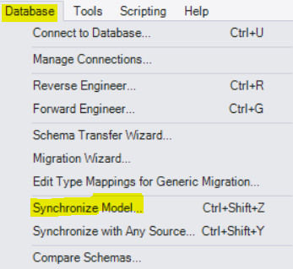

Accept the default values in the windows that follow this one

1. Forward engineer to have the changes reflected on database.

To forward engineer do the following:

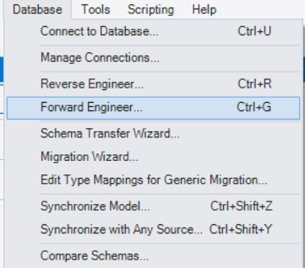

Accept the default values in the windows that follow this one

1. After the forward engineer is complete without errors you should see **car_fuel** database with the new tables and columns
2. Now move to the query tab

To open new Query tab:

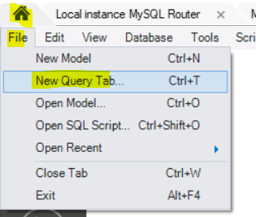

1. Run the following code in new query tab to create relationship/ foreign keys.

To create transmission_id as foreign key run the following code.

*ALTER table car_fuel.fuel_consumption*

*ADD FOREIGN KEY transmission_id(transmission_id)*

*REFERENCES transmission(transmission_id)*

*ON DELETE NO ACTION*

*ON UPDATE CASCADE*;

To create fuel_type_id as foreign key run the following code.

*ALTER table car_fuel.fuel_consumption*

*ADD FOREIGN KEY fuel_type_id (fuel_type_id)*

*REFERENCES fuel_type (fuel_type_id)*

*ON DELETE NO ACTION*

*ON UPDATE CASCADE;*

1. Generate the SQL backup file to be uploaded to Brightspace.
   1. Server -> Data Export -> (Select car_fuel database) -> Export Progress -> Start Export
   2. Make sure to check the ‘Export to Self-Contained File’ radio button
   3. Make sure you choose ‘Dump Structure and Data’ from the drop-down list

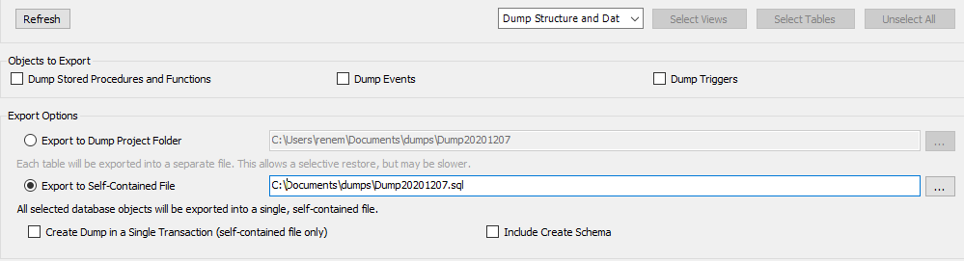

***Go to the directory where the .SQL file is saved on your PC and upload it to Brightspace (This .SQL file is your backup)***

**Optional Verification Step:**

To make sure your relationships are set up you can do a reverse engineer to view your ERD as done in Lab 4. It should look something like below:

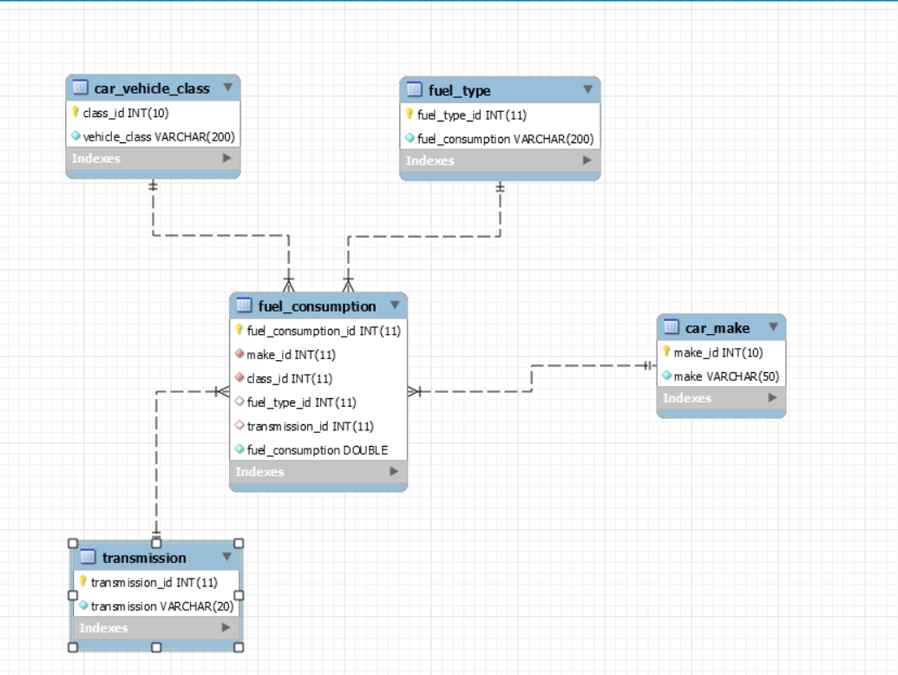

**Lab Grading Rubric (3%)**

|  |  |
| --- | --- |
| Database backup (This is the .SQL file that you generate in step 7) | /3 |
| Total | /3 |
| Comments |  |

**References:**

**The dataset used in this lab is taken from the resources below:**

Open Government. (n.d.). Fuel consumption ratings. Retrieved from <https://open.canada.ca/data/en/dataset/98f1a129-f628-4ce4-b24d-6f16bf24dd64>

Contains information licensed under the Open Government Licence – Canada ( <https://open.canada.ca/en/open-government-licence-canada> )